

Travlr Getaways – Travel Booking Website

CS 465 Project Software Design Document
Version 1.0

Table of Contents

CS 465 Project Software Design Document 1
Table of Contents 2
Document Revision History 2
Executive Summary 3
Design Constraints 3
System Architecture View 4
Component Diagram 4
Sequence Diagram 6
Class Diagram 7
API Endpoints 8
The User Interface 9

Document Revision History

Version | Date | Author | Comments
1.0 | 09/21/25 | Dylan Ngu | Completed Executive Summary, Design Constraints, and Component Diagram
1.1 | 10/09/25 | Dylan Ngu | Revised Design Constraints
1.2 | 10/09/25 | Dylan Ngu | Completed Sequence Diagram, Class Diagram, and API Endpoints Table
1.3 | 10/19/2025 | Dylan Ngu | Completed API Endpoints and User Interface sections

Executive Summary

This Software Design Document proposes the architecture for Travlr Getaways’ travel booking system, built using the MEAN stack (MongoDB, Express, Angular, Node.js). The system is structured as a two-part application: an Express-based customer website and an Angular single-page application (SPA) for administrators, both supported by a unified Node.js/Express backend and MongoDB database.

The customer-facing website will be implemented as an Express application that follows the Model-View-Controller (MVC) pattern. Express will manage URL routing, controllers, and models, while the Handlebars template engine will transform static wireframes into dynamic, server-rendered HTML views. This architecture allows database-driven content from MongoDB, such as packages, itineraries, and bookings, to be delivered directly from the server to the browser. Customers will be able to create accounts, search for packages by location and price, make reservations, and view itineraries through these dynamic templates.

The administrator interface will be built as a secure Angular SPA. Unlike the server-rendered customer site, the admin SPA will use Angular’s component-based architecture and RESTful API integration to provide a responsive and interactive dashboard. This application will allow Travlr Getaways staff to manage users, update trip packages, and adjust pricing, while role-based access controls protect administrative functionality.

At the core of the architecture, Node.js and Express.js will expose RESTful APIs that serve both applications, handling authentication, business logic, and secure data exchange. MongoDB will act as the central data store, offering flexibility through its schema-less design to accommodate evolving package details and user data. Together, the MEAN stack ensures a consistent end-to-end JavaScript environment, enabling reliable, database-driven content delivery from the backend to the client while maintaining scalability and ease of future enhancements.

Design Constraints

The design of the Travlr Getaways web application is shaped by constraints that directly influenced the architectural choices. The customer-facing site must deliver a smooth, user-friendly experience and provide dynamic, content-driven pages such as travel packages, itineraries, and booking confirmations. These requirements make an Express application with Handlebars templating ideal, as it allows server-side rendering of database-driven content while maintaining fast page loads and reliable performance. In contrast, the administrator interface must be feature-rich, providing staff with tools to manage customers, trip packages, and pricing efficiently. An Angular single-page application (SPA) is well-suited for this, offering a highly interactive interface, seamless navigation, and real-time updates via RESTful APIs.

Developing the Travlr Getaways web application using the MEAN stack introduces several inherent constraints that shape its architecture and functionality. Because the MEAN stack relies entirely on JavaScript, both client and server logic must follow JavaScript conventions, limiting flexibility in using other programming languages or frameworks. MongoDB’s NoSQL structure offers flexibility but lacks enforced relationships, requiring careful schema design to maintain data consistency. Express.js demands a well-organized MVC structure to ensure scalability and secure routing, while Angular’s SPA architecture, though powerful, can increase application complexity and impact performance on lower-end devices. Node.js supports efficient, asynchronous operations but is less suited for CPU-intensive tasks, making optimization essential. Together, these constraints define a development environment that favors rapid, scalable, and modular design, while requiring disciplined coding practices and thoughtful integration across all layers of the MEAN stack.

System Architecture View

Component Diagram

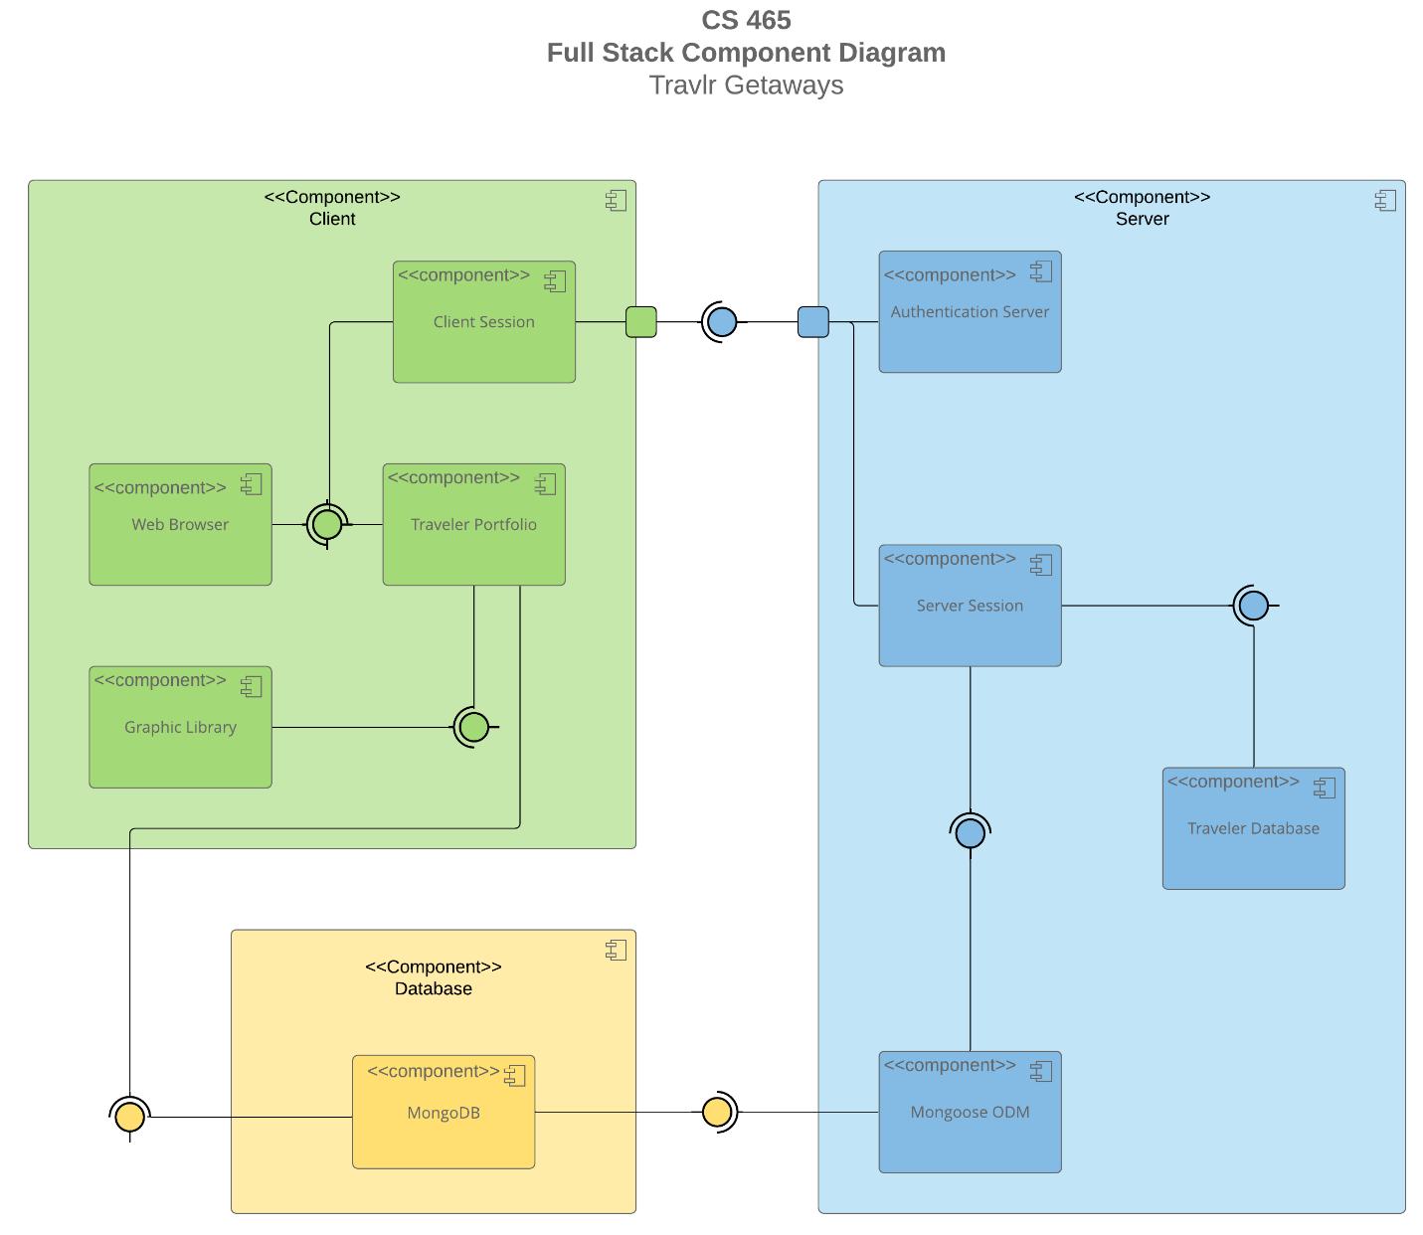

A text version of the component diagram is available: CS 465 Full Stack Component Diagram Text Version.

The Travlr Getaways web application is designed as a layered system that separates the client, server, and database responsibilities while ensuring seamless interaction between components. The architecture is organized into three primary component groups: Client, Server, and Database.

The Client layer represents the user-facing side of the application. It includes the Web Browser, which interacts directly with users, the Client Session, which manages session state and user authentication on the client side, and the Traveler Portfolio, which provides dynamic content such as user accounts, bookings, and itineraries. The Graphic Library component supports the Traveler Portfolio by providing visual assets and UI elements. The Web Browser communicates with both the Client Session and the Traveler Portfolio, leveraging required interfaces to request and render data dynamically. The Traveler Portfolio also interacts with the Graphic Library to display visual content and interfaces directly to the MongoDB database to retrieve content-driven information.

The Server layer handles business logic, authentication, and data management. The Authentication Server validates user credentials and manages secure access, while the Server Session maintains server-side session state and facilitates communication between the client and the database. The Traveler Database component on the server stores user-specific data, and the Mongoose ODM component provides an object-document mapping interface between Node.js/Express and MongoDB.

The Database layer consists of MongoDB, which serves as the persistent data store for the application. MongoDB is accessed by the Mongoose ODM, which maps database documents to JavaScript objects, enabling the server and client components to work with structured data efficiently.

The diagram shows a clear flow of required interfaces between components. On the client side, the Web Browser depends on the Client Session and Traveler Portfolio, which in turn rely on the Graphic Library and MongoDB. On the server side, Mongoose interfaces with MongoDB, the Server Session interfaces with Mongoose and the Traveler Database, and the Client Session connects to the Authentication Server for secure access. These connections ensure that content-driven features on the customer-facing site and feature-rich functionality on the admin SPA are supported reliably by a centralized backend and database.

Sequence Diagram

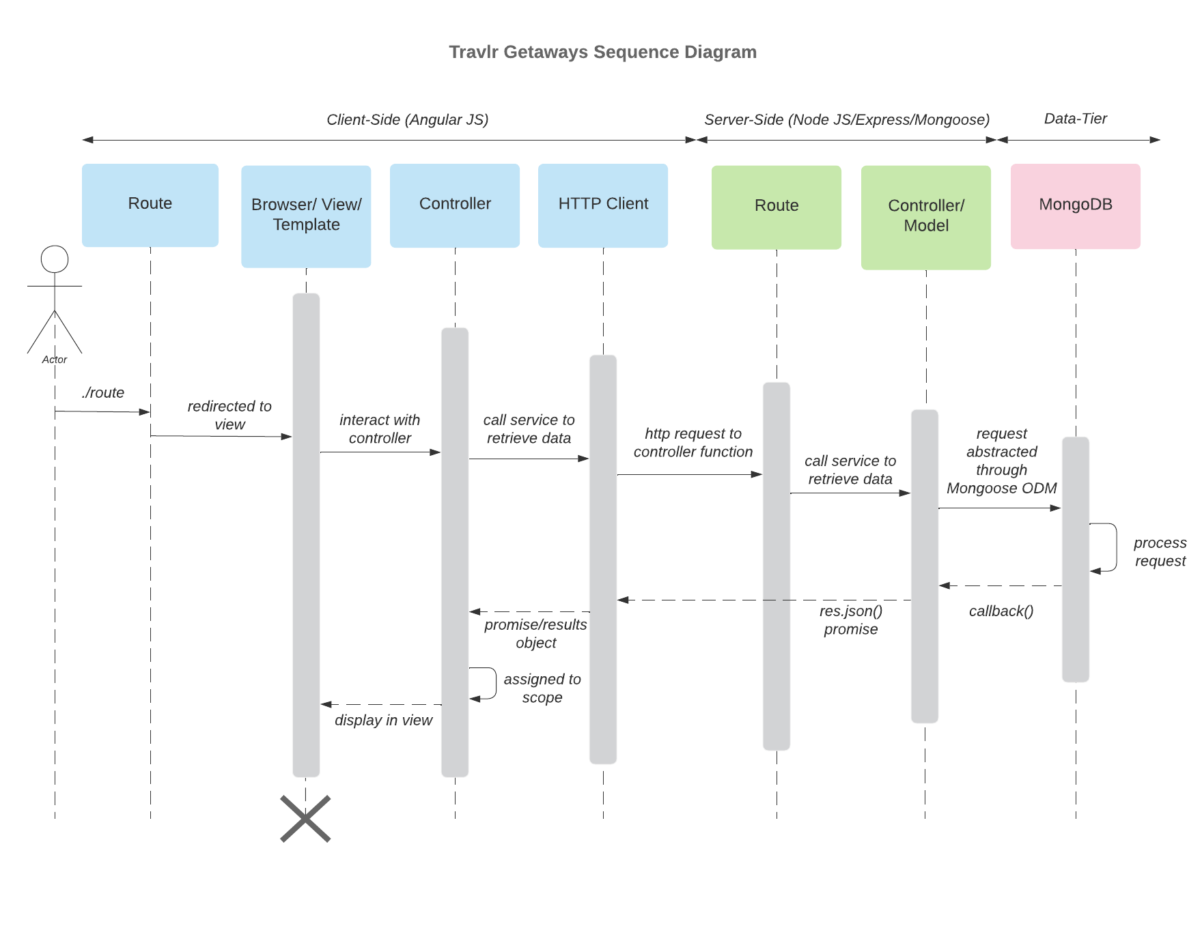

The Travlr Getaways web application follows a structured sequence of interactions across three tiers: the Client-Side (Angular), the Server-Side (Node.js/Express/Mongoose), and the Data Tier (MongoDB). This layered architecture enables efficient communication between the client interface, backend services, and database to support both customer and administrator operations.

The process begins on the client side, where the user (actor) initiates an action through the Route component; for example, navigating to a page such as /trips or /signin. The route redirects the user to the corresponding Browser/View/Template, which renders the appropriate view based on Angular routing. The View interacts with the Controller, which handles user input and determines the necessary data or actions.

When the Controller requires data, for instance, retrieving available trips or validating login credentials, it calls a service through the HTTP Client. The HTTP Client sends an HTTP request to the server-side route defined in Express. On the server, this request is handled by the appropriate Route component, which delegates processing to a Controller/Model function. The controller then calls the service responsible for accessing or updating data through the Mongoose ODM (Object Data Modeling) layer.

The Mongoose layer abstracts database operations, translating JavaScript objects into MongoDB documents. When the MongoDB database receives the request, it processes the query and sends the result back through the callback chain. The Server Controller formats this data as a JSON object (res.json()) and returns it to the HTTP Client on the client side.

The HTTP Client receives the promise or response object and passes it back to the Angular Controller, which assigns the data to the appropriate scope or component state. The View/Template is then dynamically updated to display the results; for example, showing a list of travel packages or confirming a booking.

Example Process - Trips: When a user views available trips, the Angular Controller requests data from the /api/trips route. Express retrieves the data from MongoDB and returns it as JSON, which Angular then renders dynamically in the trip list template.

Class Diagram

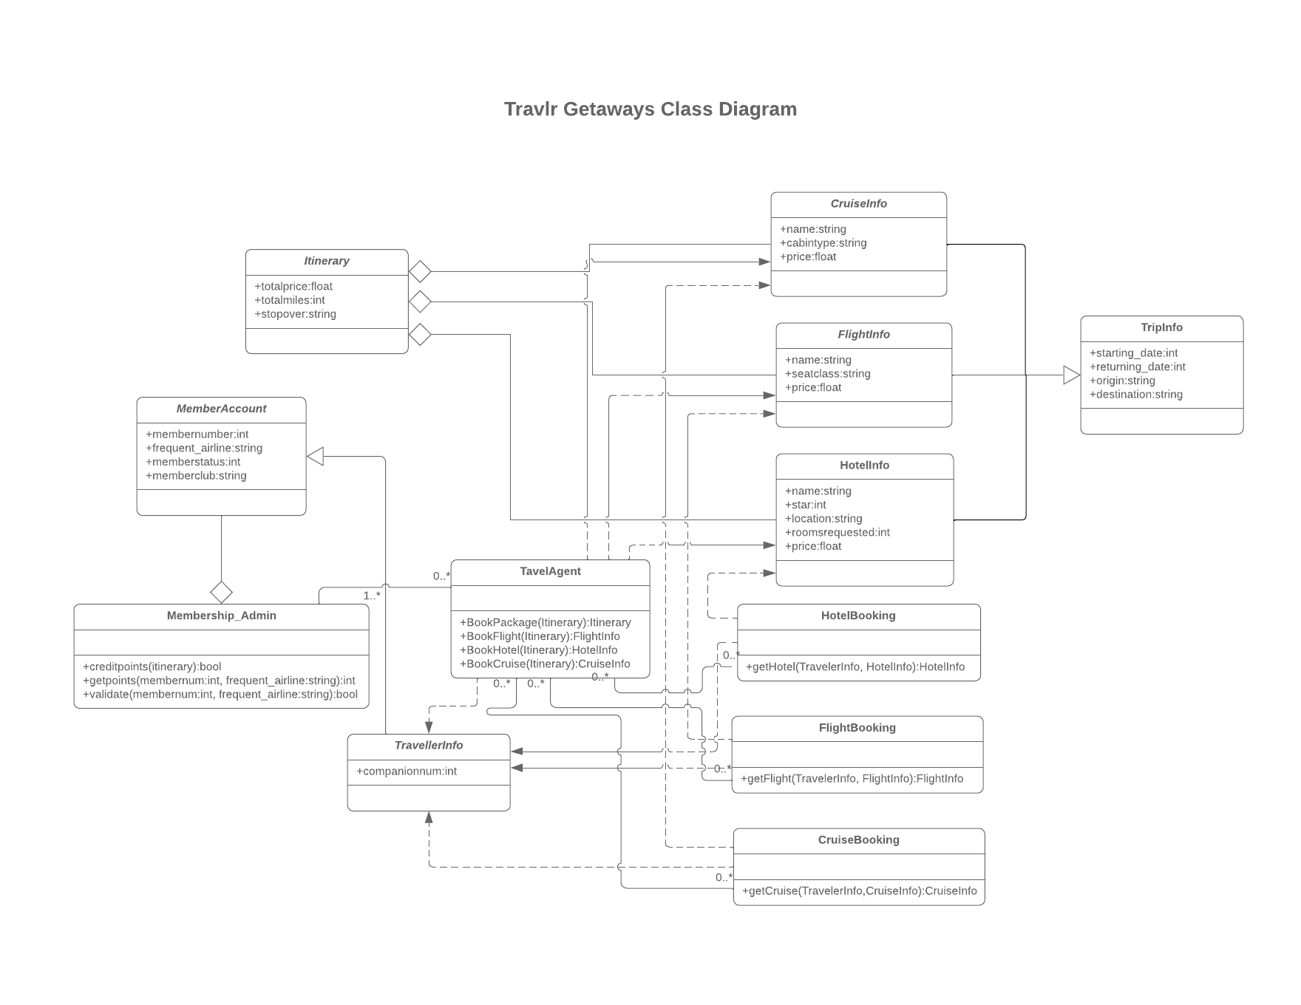
The Travlr Getaways web application uses an object-oriented JavaScript design to model the main entities involved in travel booking, user management, and itinerary coordination. The MemberAccount and Membership_Admin classes manage customer profiles and membership privileges, handling account validation and reward point processing. The TravelAgent class serves as the core business logic component, coordinating bookings for flights, hotels, and cruises, while the TravellerInfo class maintains traveler details used throughout the booking process.

The Itinerary and TripInfo classes represent travel schedules and trip details, providing structure for organizing multiple travel services within a single booking. Supporting service classes, (FlightInfo, HotelInfo, and CruiseInfo) store data about travel options, while their corresponding booking classes, (FlightBooking, HotelBooking, and CruiseBooking) manage confirmed reservations and link travelers to selected services.

These classes are interconnected through clear associations, with the TravelAgent acting as a central coordinator between user accounts, itineraries, and booking services. This modular class design promotes scalability, reusability, and maintainability within the MEAN stack architecture, allowing Travlr Getaways to efficiently handle both customer-facing and administrative travel operations.

API Endpoints

Method | Purpose | URL | Notes
GET | Retrieve a list of all trips | /api/trips | Returns a list of all the trips
POST | Add a new trip to database | /api/trips | Creates a new trip to be added to database, this method requires admin authorization
GET | Retrieve a single trip | /api/trips/:tripcode | Returns single trip instance, identified by the tripcode passed on the request URL.
PUT | Update a single trip | /api/trips/:tripcode | Changes data for an existing trip, identified by the tripcode. Method requires admin authorization.
DELETE | Deletes a single trip | /api/trips/:tripcode | Deletes a single trip from the database, identified by the tripcode. Method requires authorization.
POST | User login | /api/login | Compares user credentials to ones stored in database. If there’s a match, user can sign in.
POST | Create new user account | /api/register | Registers a new user by creating a new user account to be stored in database.

The User Interface

Add trip screen:
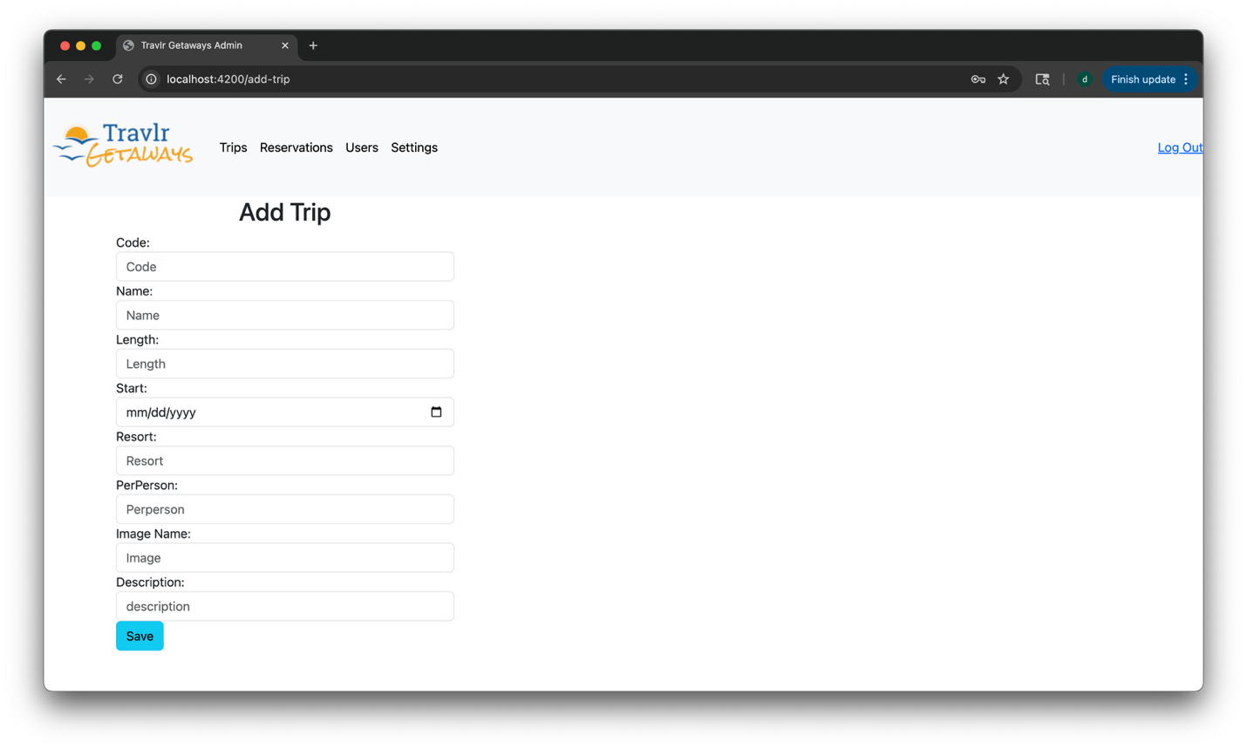
Unique trip, added by me:
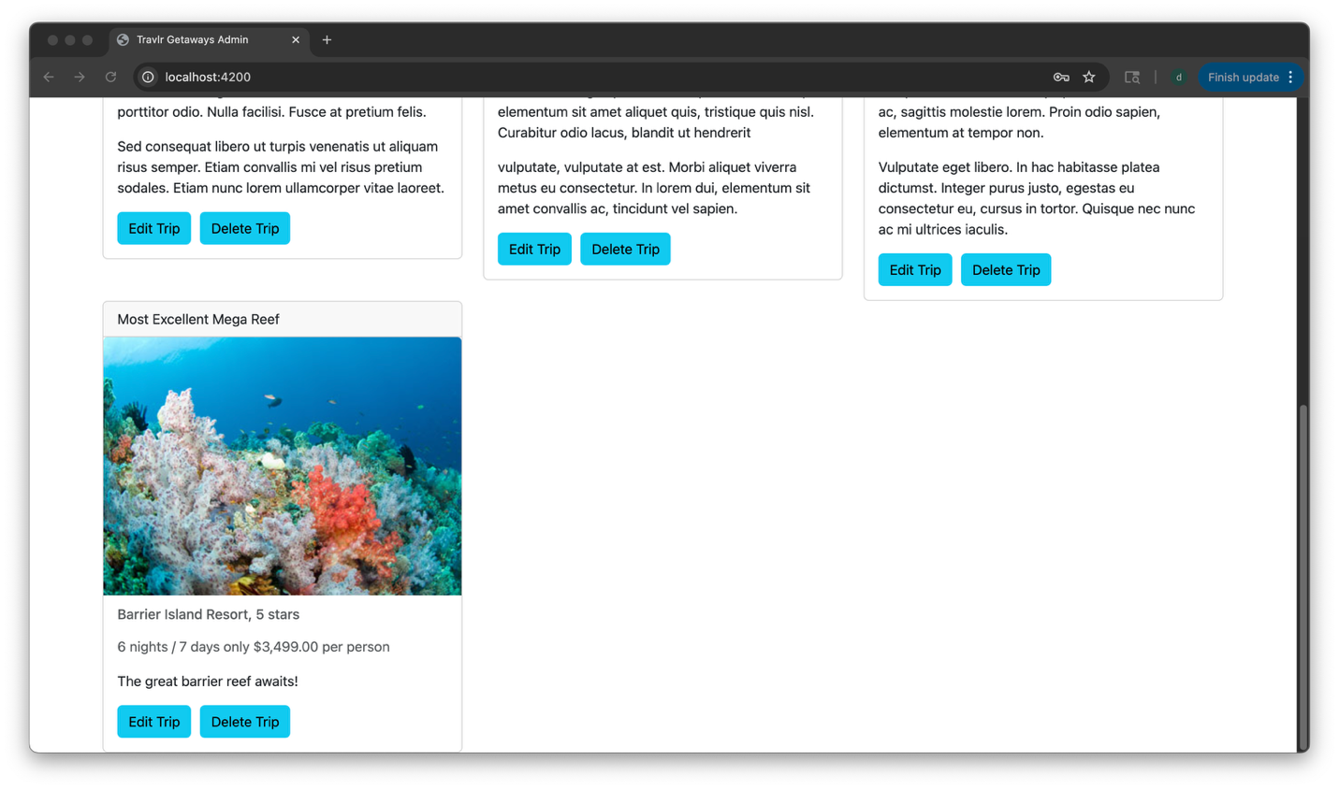

Edit Screen:
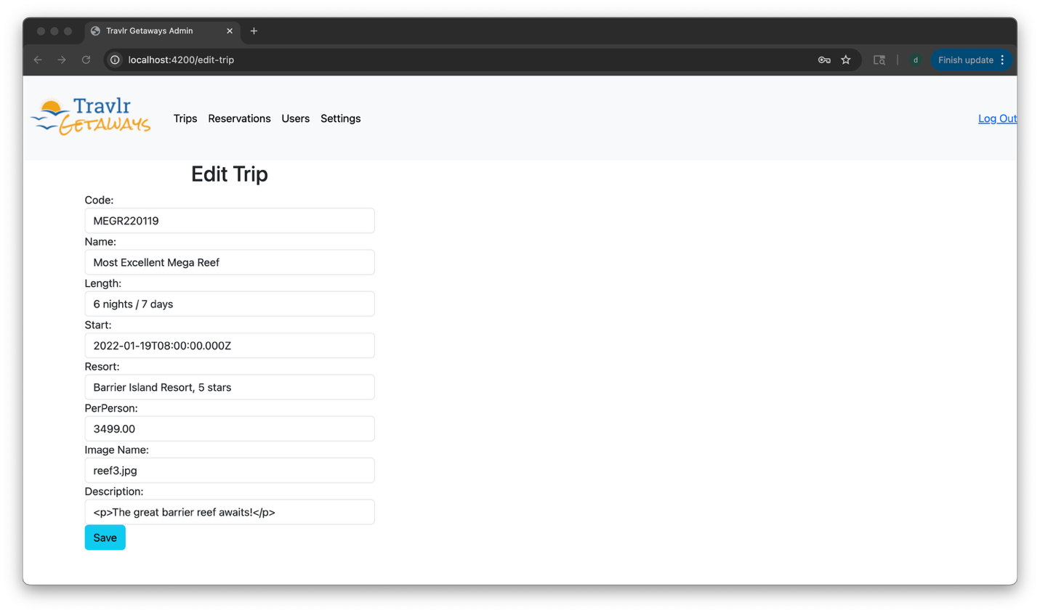
Updated screen:
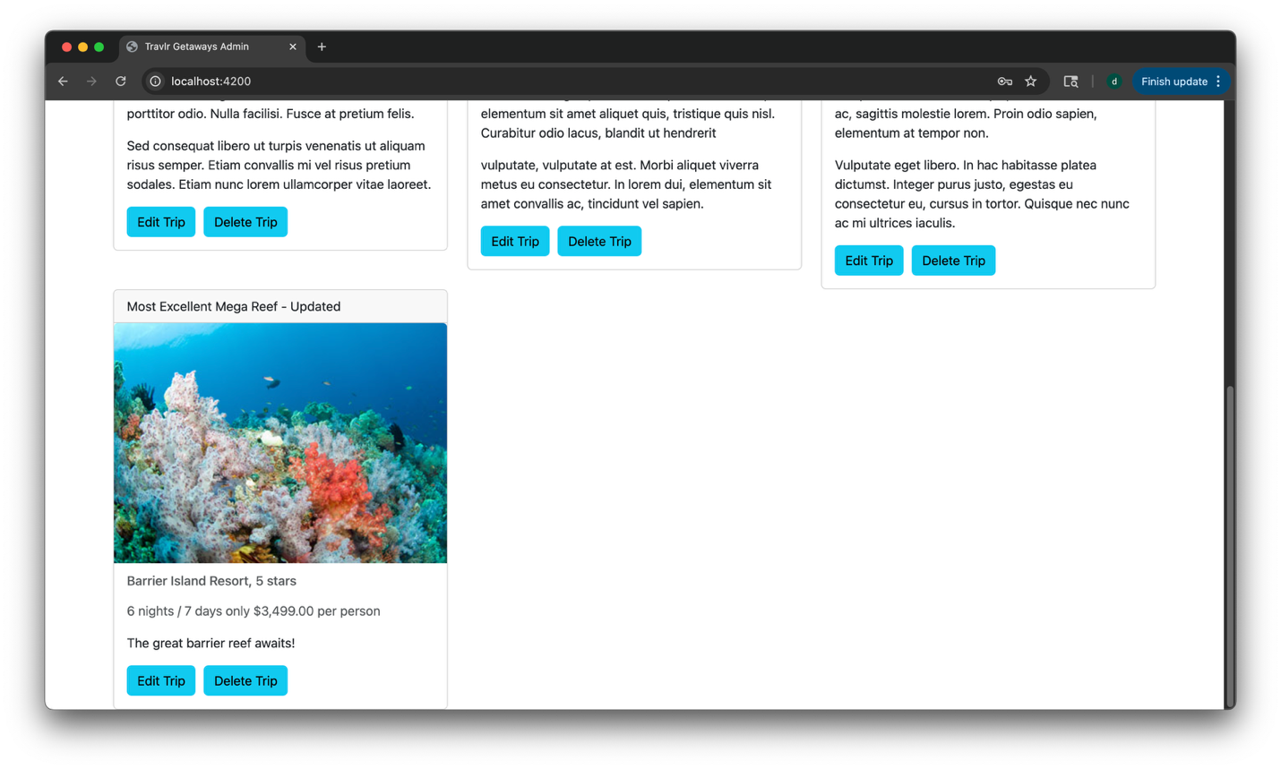

The Angular project structure differs from the Express project structure in both design and functionality. While the Express application uses a traditional Model-View-Controller (MVC) pattern with server-rendered Handlebars templates, the Angular single-page application (SPA) follows a modular, component-based architecture. Each Angular component handles its own logic, template, and styling, allowing the interface to dynamically update without requiring full page reloads. This structure enables the SPA to provide a richer and more responsive user experience than a simple web application, as data and views are updated asynchronously through API calls rather than re-rendered on the server.

The SPA’s functionality extends beyond static interactions by allowing administrators to view, edit, and manage content through reusable UI components and integrated services. These components interact directly with the Express API, providing seamless data synchronization between the client and the database. Testing the SPA involved verifying that Angular correctly communicated with the backend API to perform GET and PUT operations on MongoDB. This process included checking that data retrieved from the API displayed accurately in the admin dashboard and that updates made through the SPA were properly reflected in the database. Console logging and Postman testing were effective tools for identifying and troubleshooting any issues and verifying correct behaviors.

